**Worksheet 1.2**

**Student Name:** Sahil Kaundal **UID:** 21BCS8197

**Branch:** CSE (Lateral Entry) **Section/Group:** 20BCS-809_A

**Semester:** 4th  **Date of Performance:** 24/02/2022

**Subject Name:** Computer NetworksLab **Subject Code:** 20CSP-257

**1. Aim/Overview of the practical:**

Implement all the networking commands and show their working as output.

**2. Task to be done/ Which logistics used:**

Implement all the networking commands and show their working as output.

**3. Steps for experiment/practical/Code:**

Step 1- Open Command Prompt.

Step 2- Implement the networking command.

Step 3- Run the commands.

Step 4- Paste the output.

1. **Ping:** PING (Packet Internet Groper) command is used to check the network connectivity between host and server/host. This command takes as input the IP address or the URL and sends a data packet to the specified address with the message “PING” and get a response from the server/host this time is recorded which is called latency. Fast ping low latency means faster connection. Ping uses [**ICMP(Internet Control Message Protocol)**](https://www.geeksforgeeks.org/internet-control-message-protocol-icmp/) to send an **ICMP echo message** to the specified host if that host is available then it sends **ICMP reply message**.

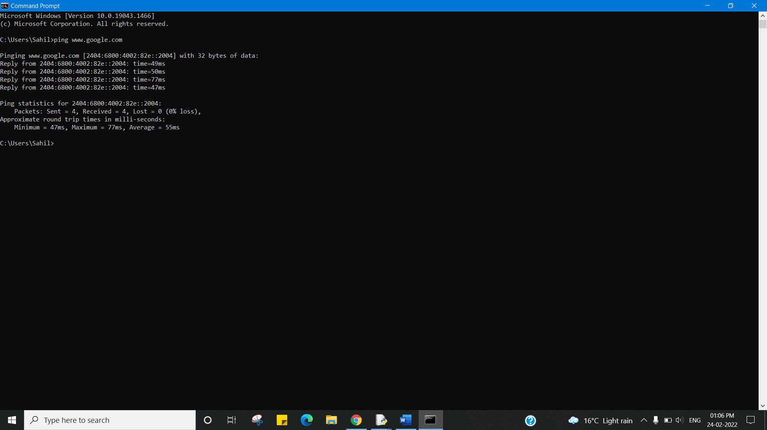

1. **Ipconfig:** The ipconfig command is used to display information about your network configuration and refresh DHCP and DNS Settings. By default, the ipconfig command displays your IP Address, Subnet Mask, and default gateway. But with correct parameters, you can get a lot more information out of it.

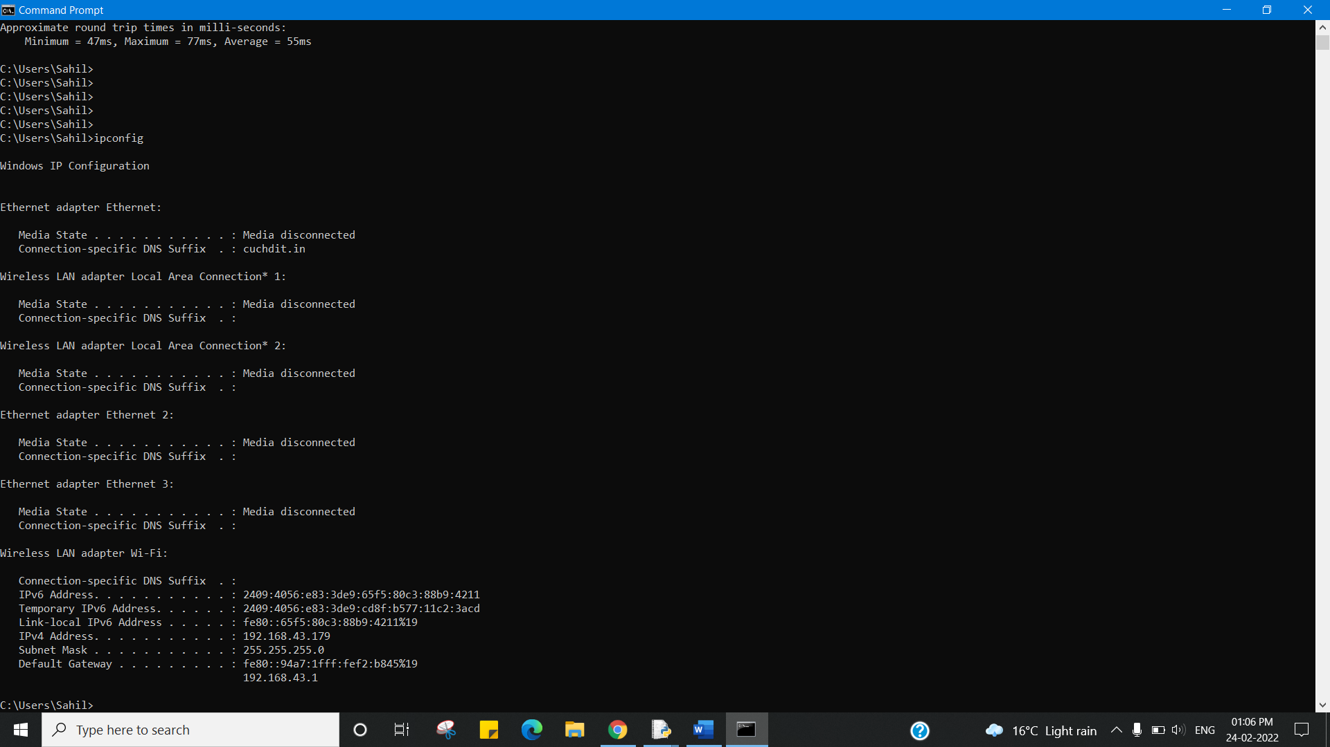

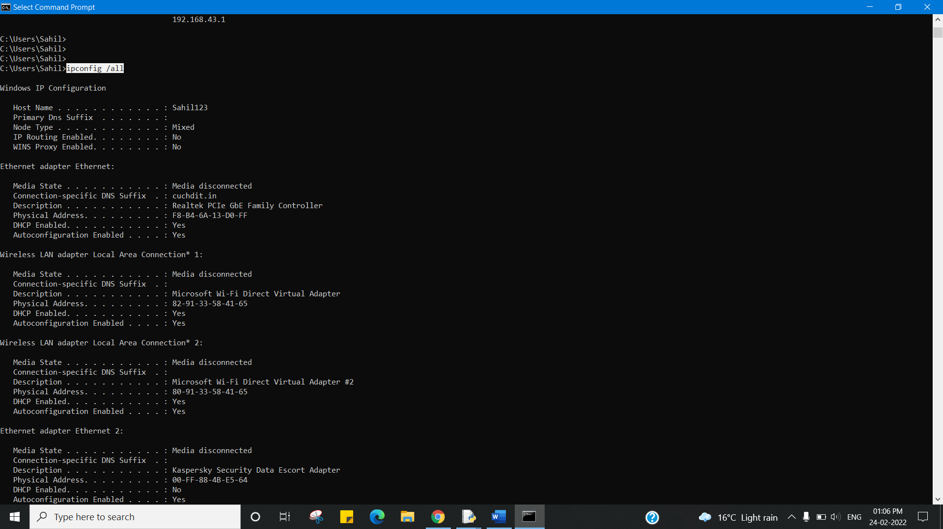

1. **Netstat:** Netstat command displays various network related information such as network connections, routing tables, interface statistics, masquerade connections, multicast memberships etc.

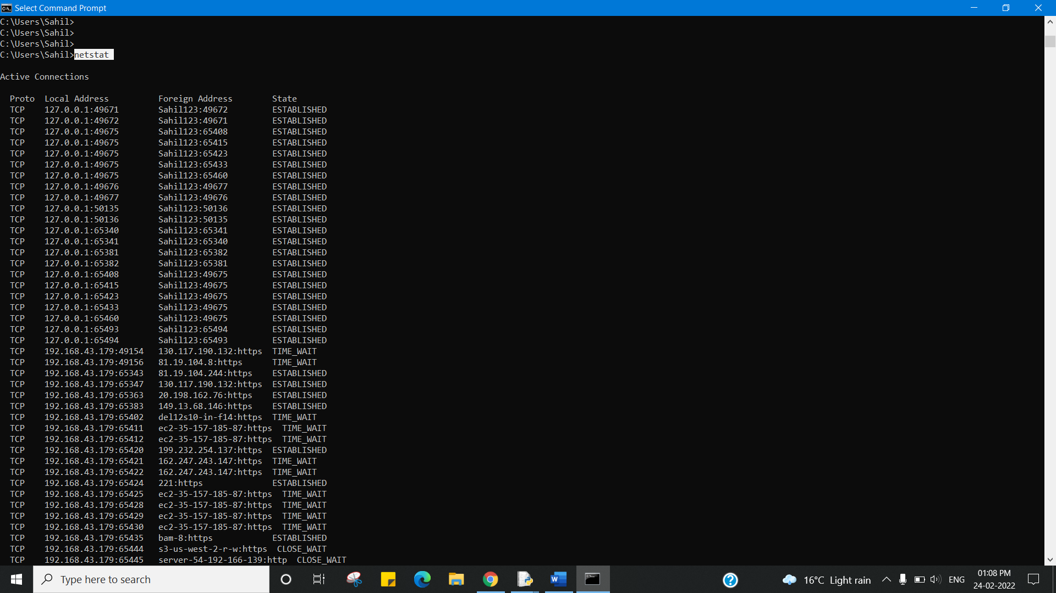

1. **Nslookup: Nslookup**(stands for “Name Server Lookup”) is a useful command for getting information from the DNS server. It is a network administration tool for querying the Domain Name System (DNS) to obtain domain name or IP address mapping or any other specific DNS record. It is also used to troubleshoot DNS-related problems.

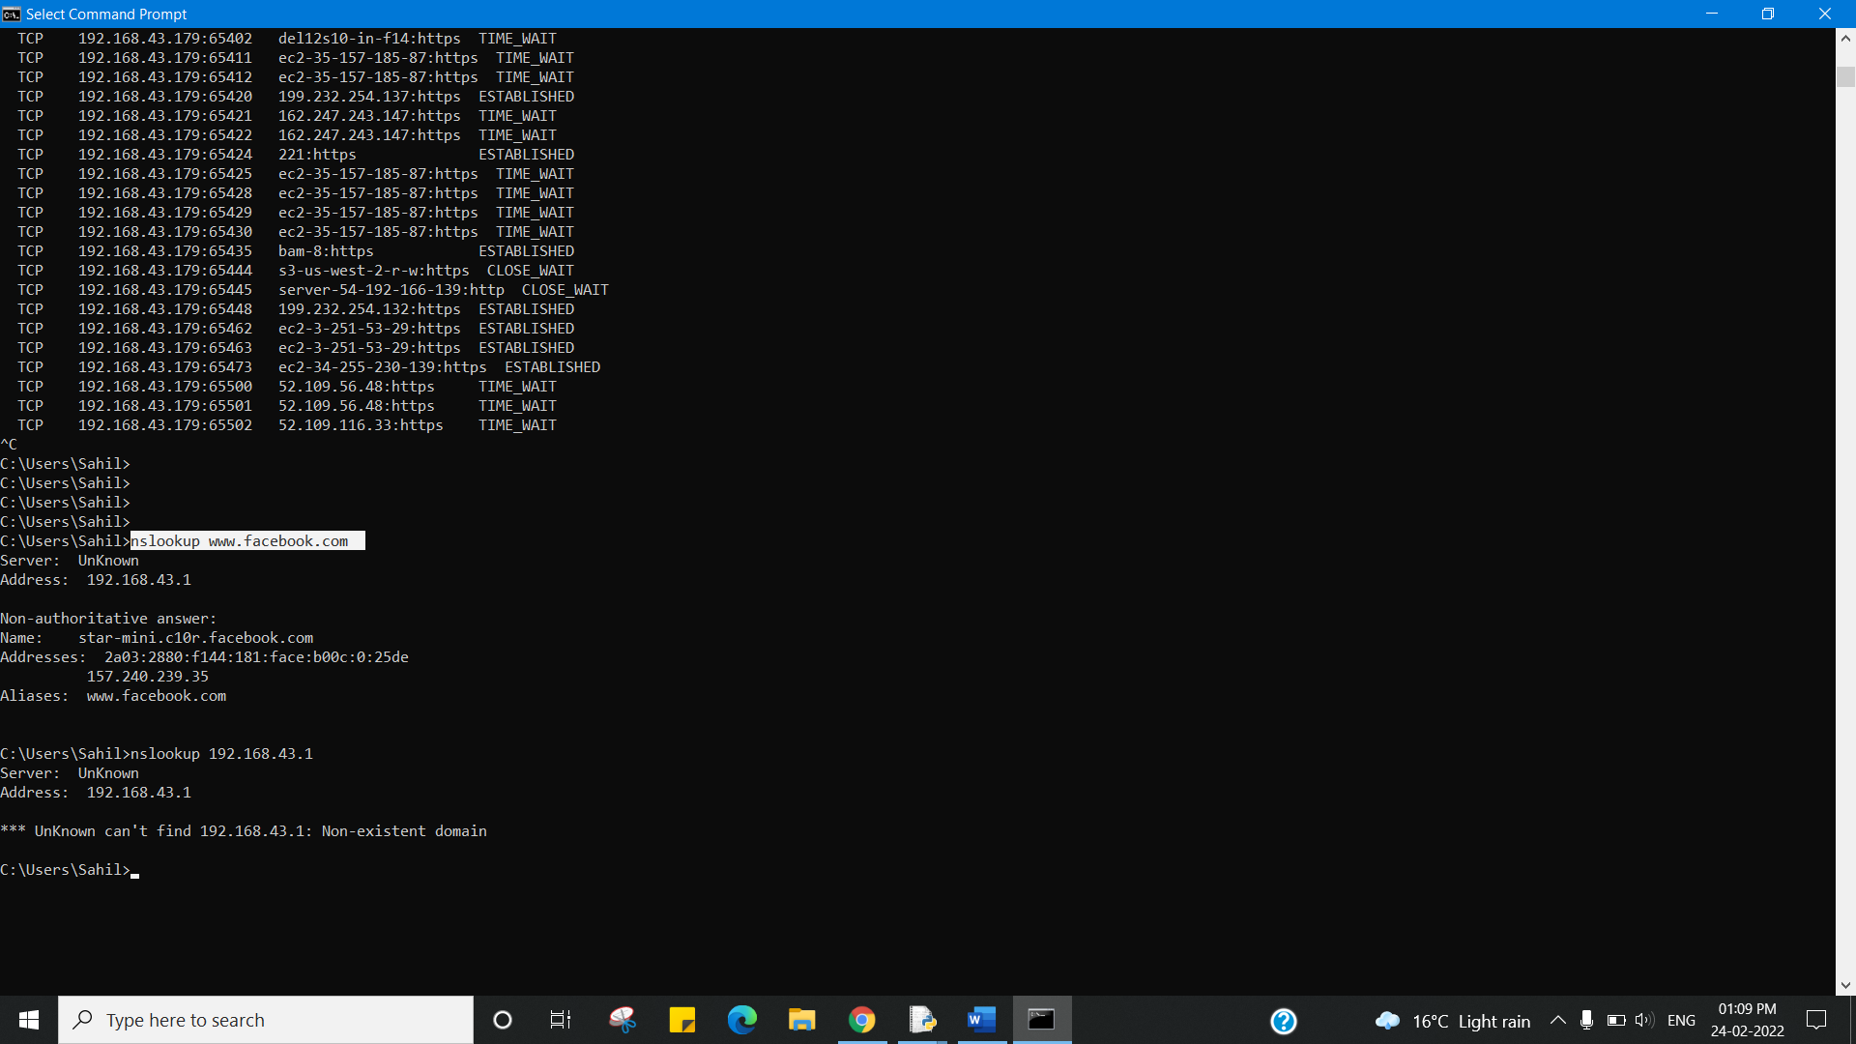

1. **Tracert:** The tracert command is a Command Prompt command that's used to show several details about the path that a packet takes from the computer or device you're on to whatever destination you specify.

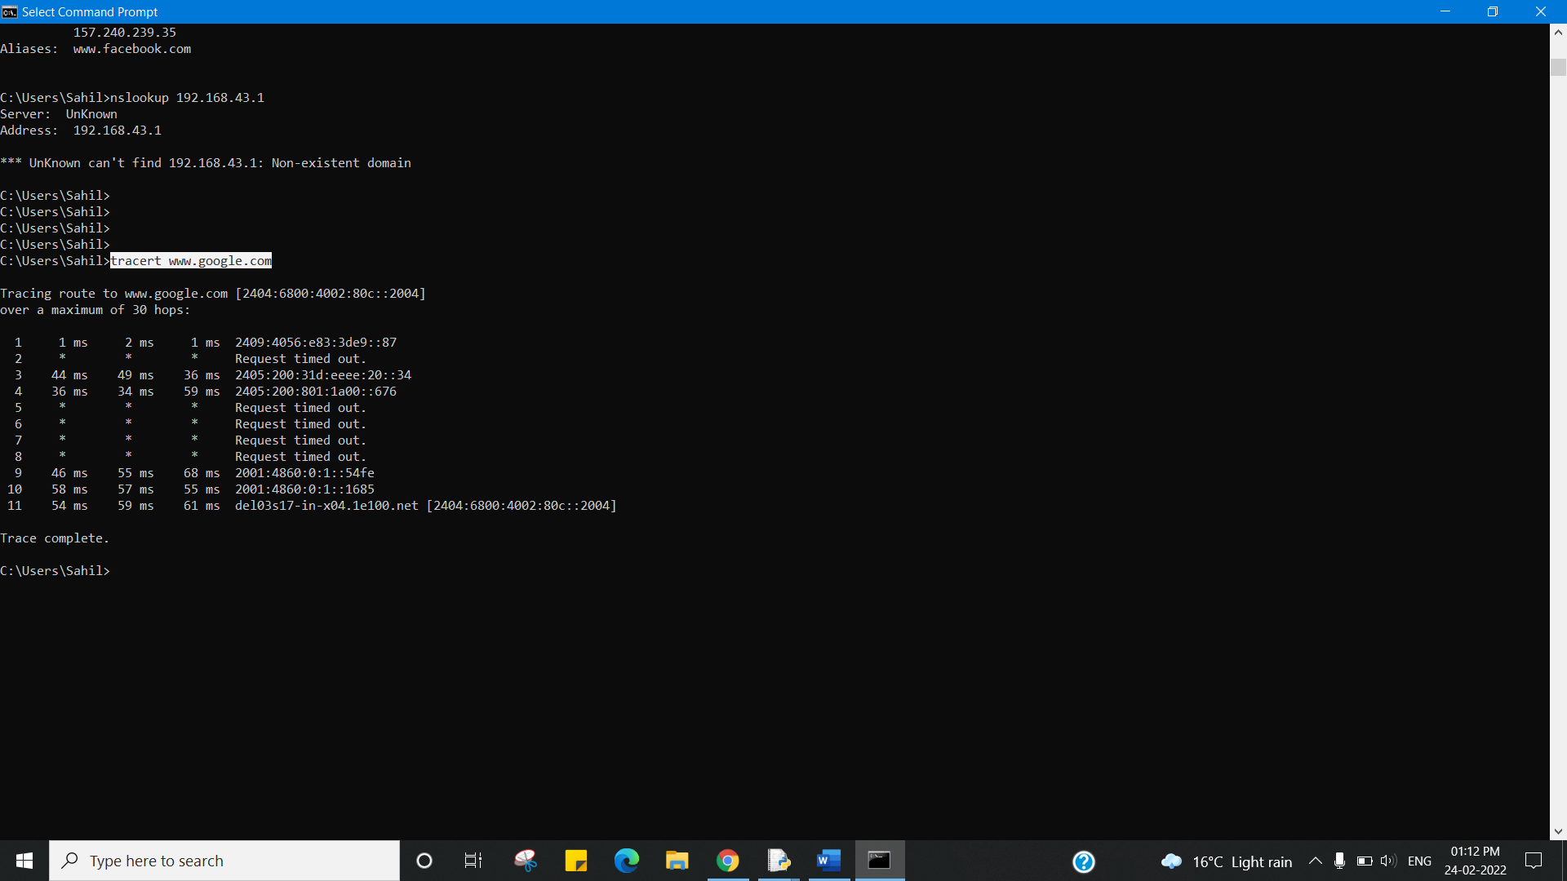

1. **Pathping:** The PathPing command is a command-line network utility supplied in Windows 2000 and beyond that combines the functionality of ping with that of tracert. It is used to locate spots that have network latency and network loss.

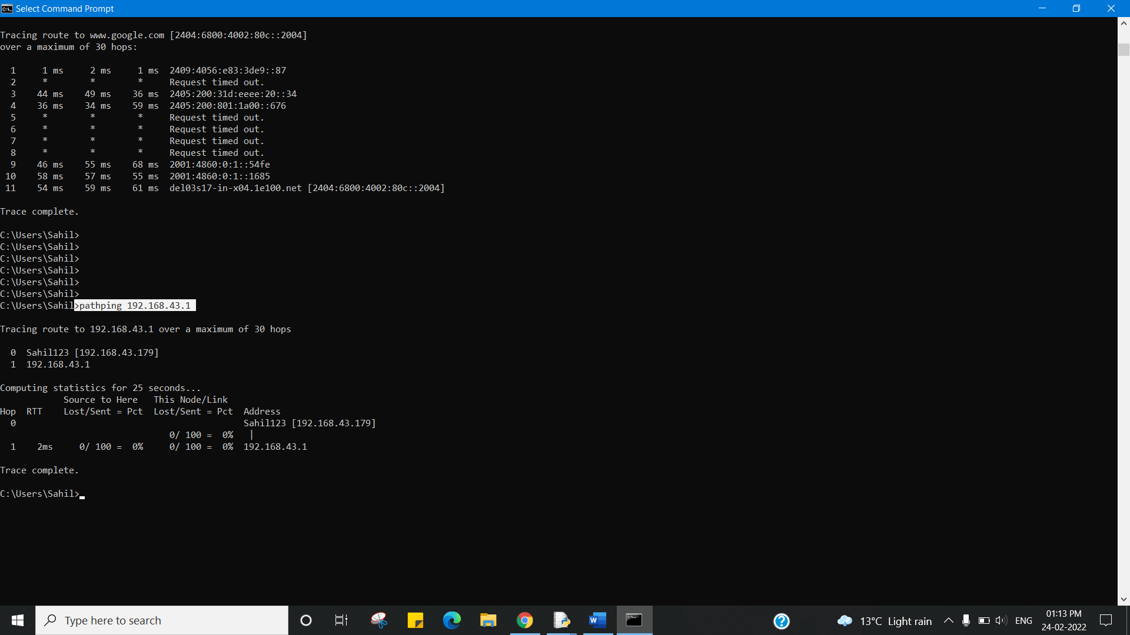

1. **Arp:** ARP Command is a TCP/IP utility used for viewing and modifying the local Address Resolution Protocol (ARP) cache. ARP Cache contains recently resolved MAC addresses of Internet Protocol (IP) hosts on the network. Run ARP command without any arguements will display a list of the command's parameters.
2. **RARP** provides the opposite service to ARP in that it is used when only the ethernet address is known and the IP address is needed. RARP requests are most commonly sent by diskless clients and JumpStart clients during bootup.

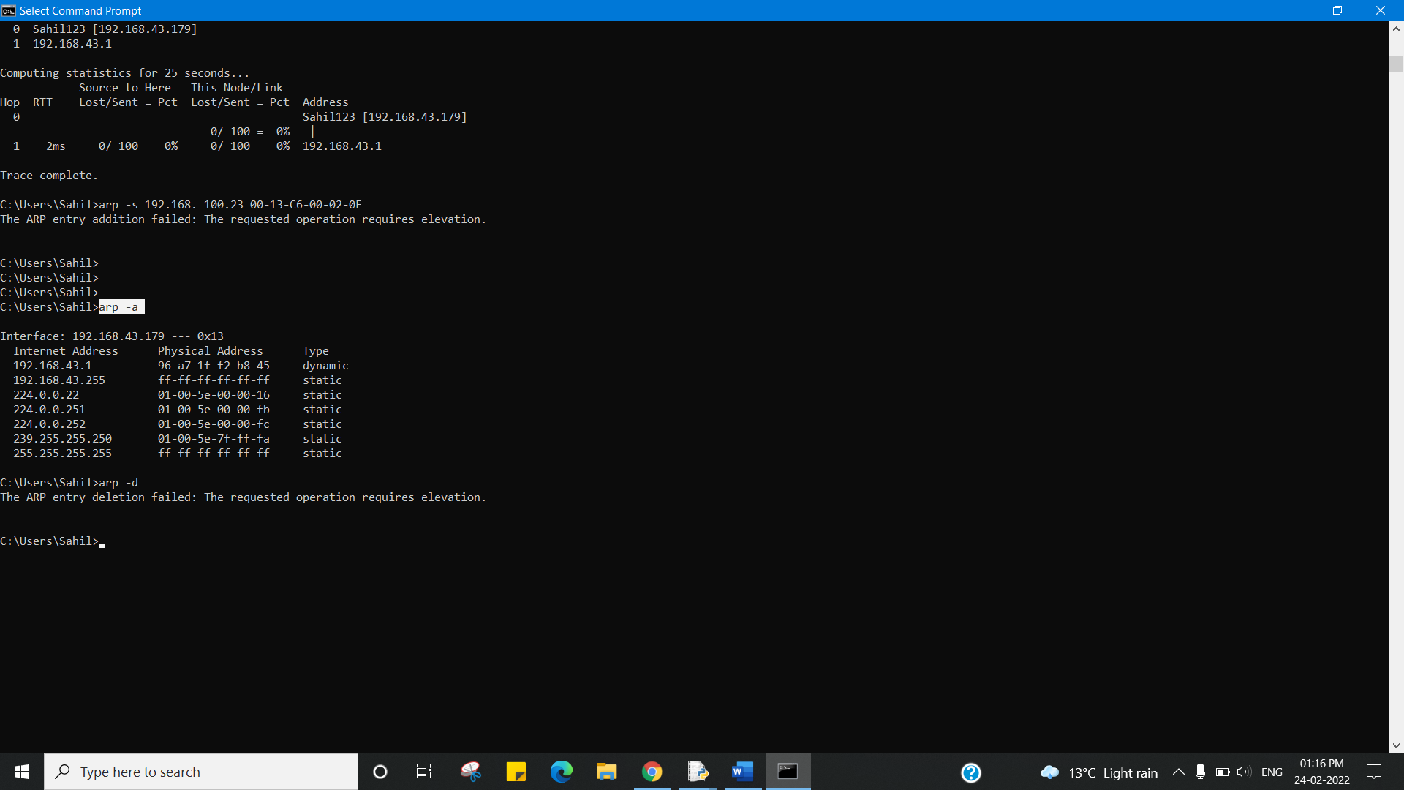

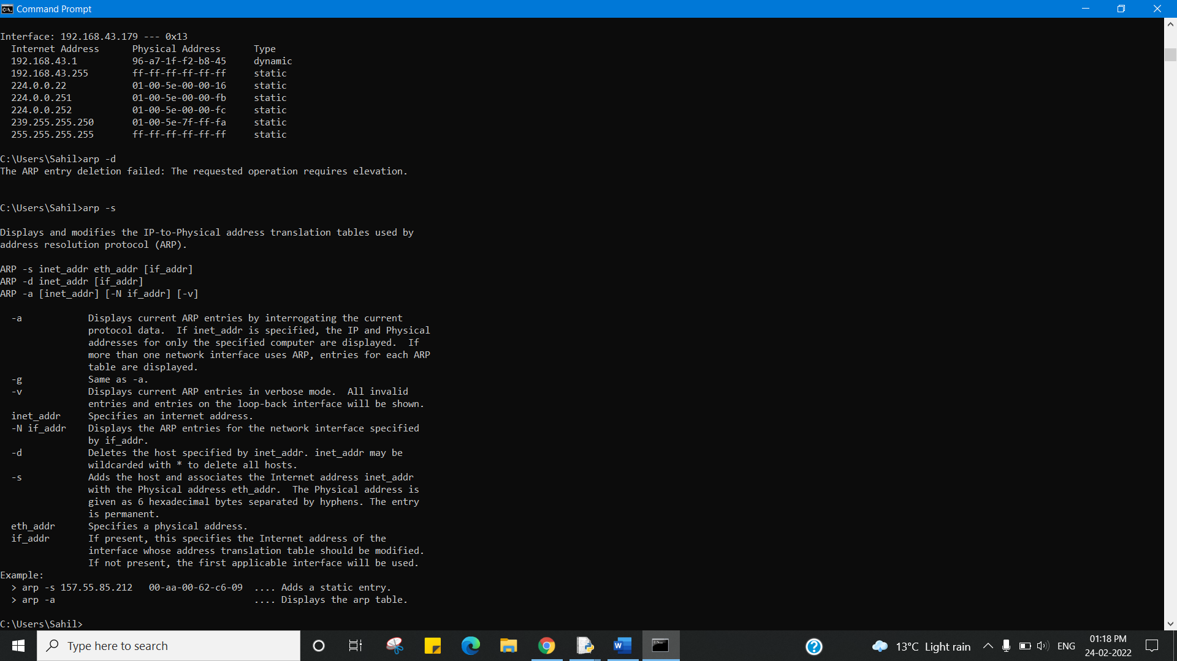

1. **Hostname:** hostname command in Linux is used to obtain the DNS(Domain Name System) name and set the system’s hostname or NIS(Network Information System) domain name. A hostname is a name which is given to a computer and it attached to the network. Its main purpose is to uniquely identify over a network.

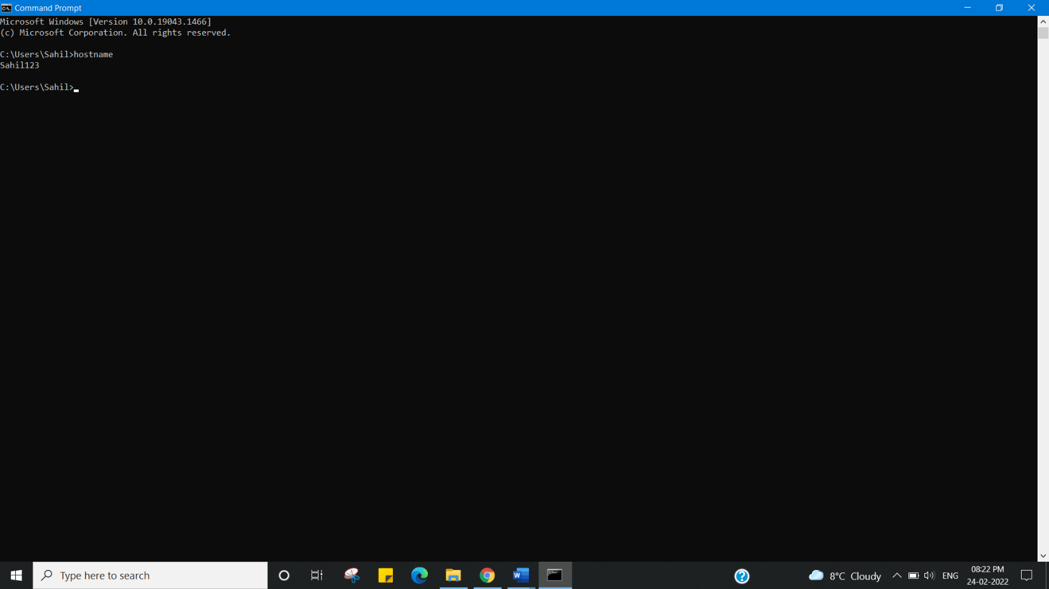

4. **Result/Output/Writing Summary:**

I have successfully completed this experiment.

**Learning outcomes (What I have learnt):**

1. Use of ipconfig command.

2. Use of ping command.

3. Use of tracert command.

4. Use of netstat command.

5. Use of arp command.

6. Use of nslookup command.

7. Use of pathping command.

8. Use of hostname command.

9. Use of rarp command

**Evaluation Grid (To be created as per the SOP and Assessment guidelines by the faculty):**

|  |  |  |  |
| --- | --- | --- | --- |
| Sr. No. | Parameters | Marks Obtained | Maximum Marks |
| 1. |  |  |  |
| 2. |  |  |  |
| 3. |  |  |  |
|  |  |  |  |